## **Checkout issue #1: Sign-in**



**Situation:**

A significant number of customers for Tee’s Shirts are abandoning the checkout process when they reach the sign-in page. The page asks the customer to sign in or create an account.

Here is how the store’s sign-in page appears during checkout:

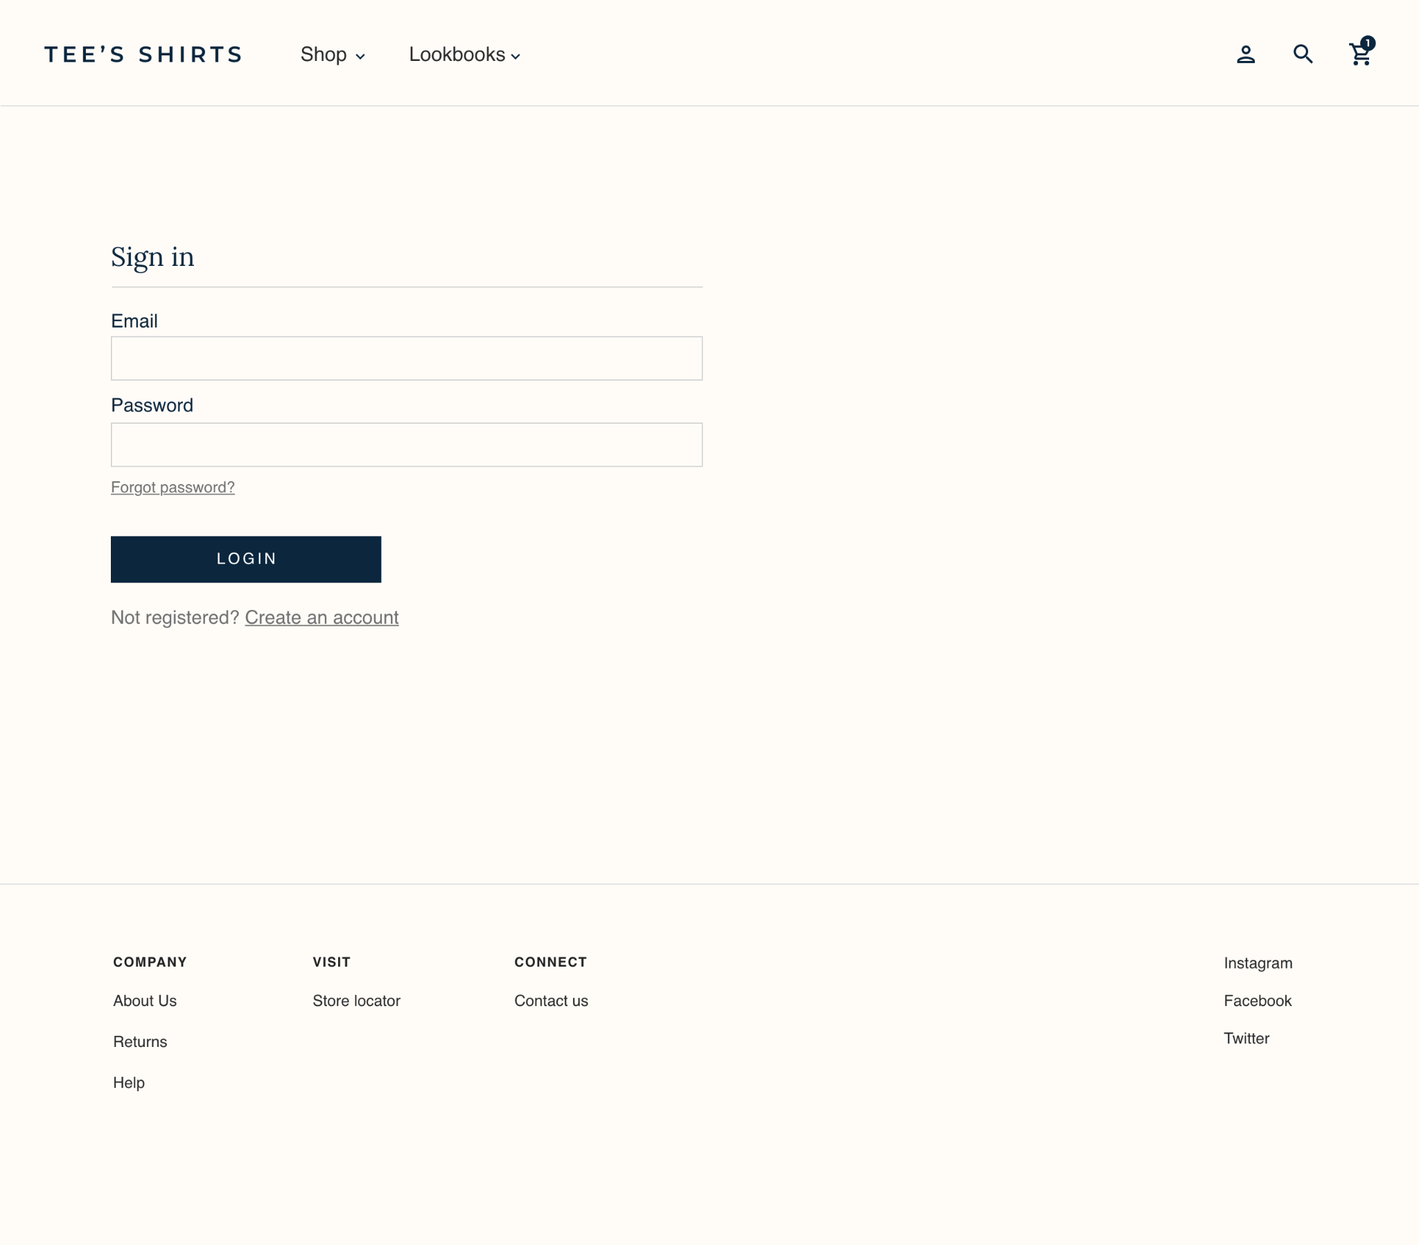

|  |
| --- |
| **Step 1: Identify the issue. Why might customers abandon the checkout process at this point?** |
| There’s no option for guest checkout. Customers may not want to sign in (for example, they may have forgotten their username or password) or complete the extra steps required to create an account. |

|  |
| --- |
| **Step 2: Suggest improvements. Identify one or two ways to address this issue and improve the checkout process.** |
| 1. Add the option for customers to check out as a guest. 2. Add social sign-in options that allow the customer to sign in using their Google, Facebook, or Apple account. This makes it easier for customers to sign in without remembering the specific username and password for their store account. Plus, it automatically fills in the information saved in the customer’s account, such as their name and address, which makes the checkout process faster. |

## 

## **Checkout issue #2: Personal information**



**Situation:**

Customers for Tee’s Shirts are also abandoning the checkout process when asked to provide their personal information. The checkout process requires them to enter the following details:

* Name
* Address
* Email address
* Home phone number
* Work phone number
* Mobile phone number
* Birthdate

Here is how the personal information fields appear during checkout:

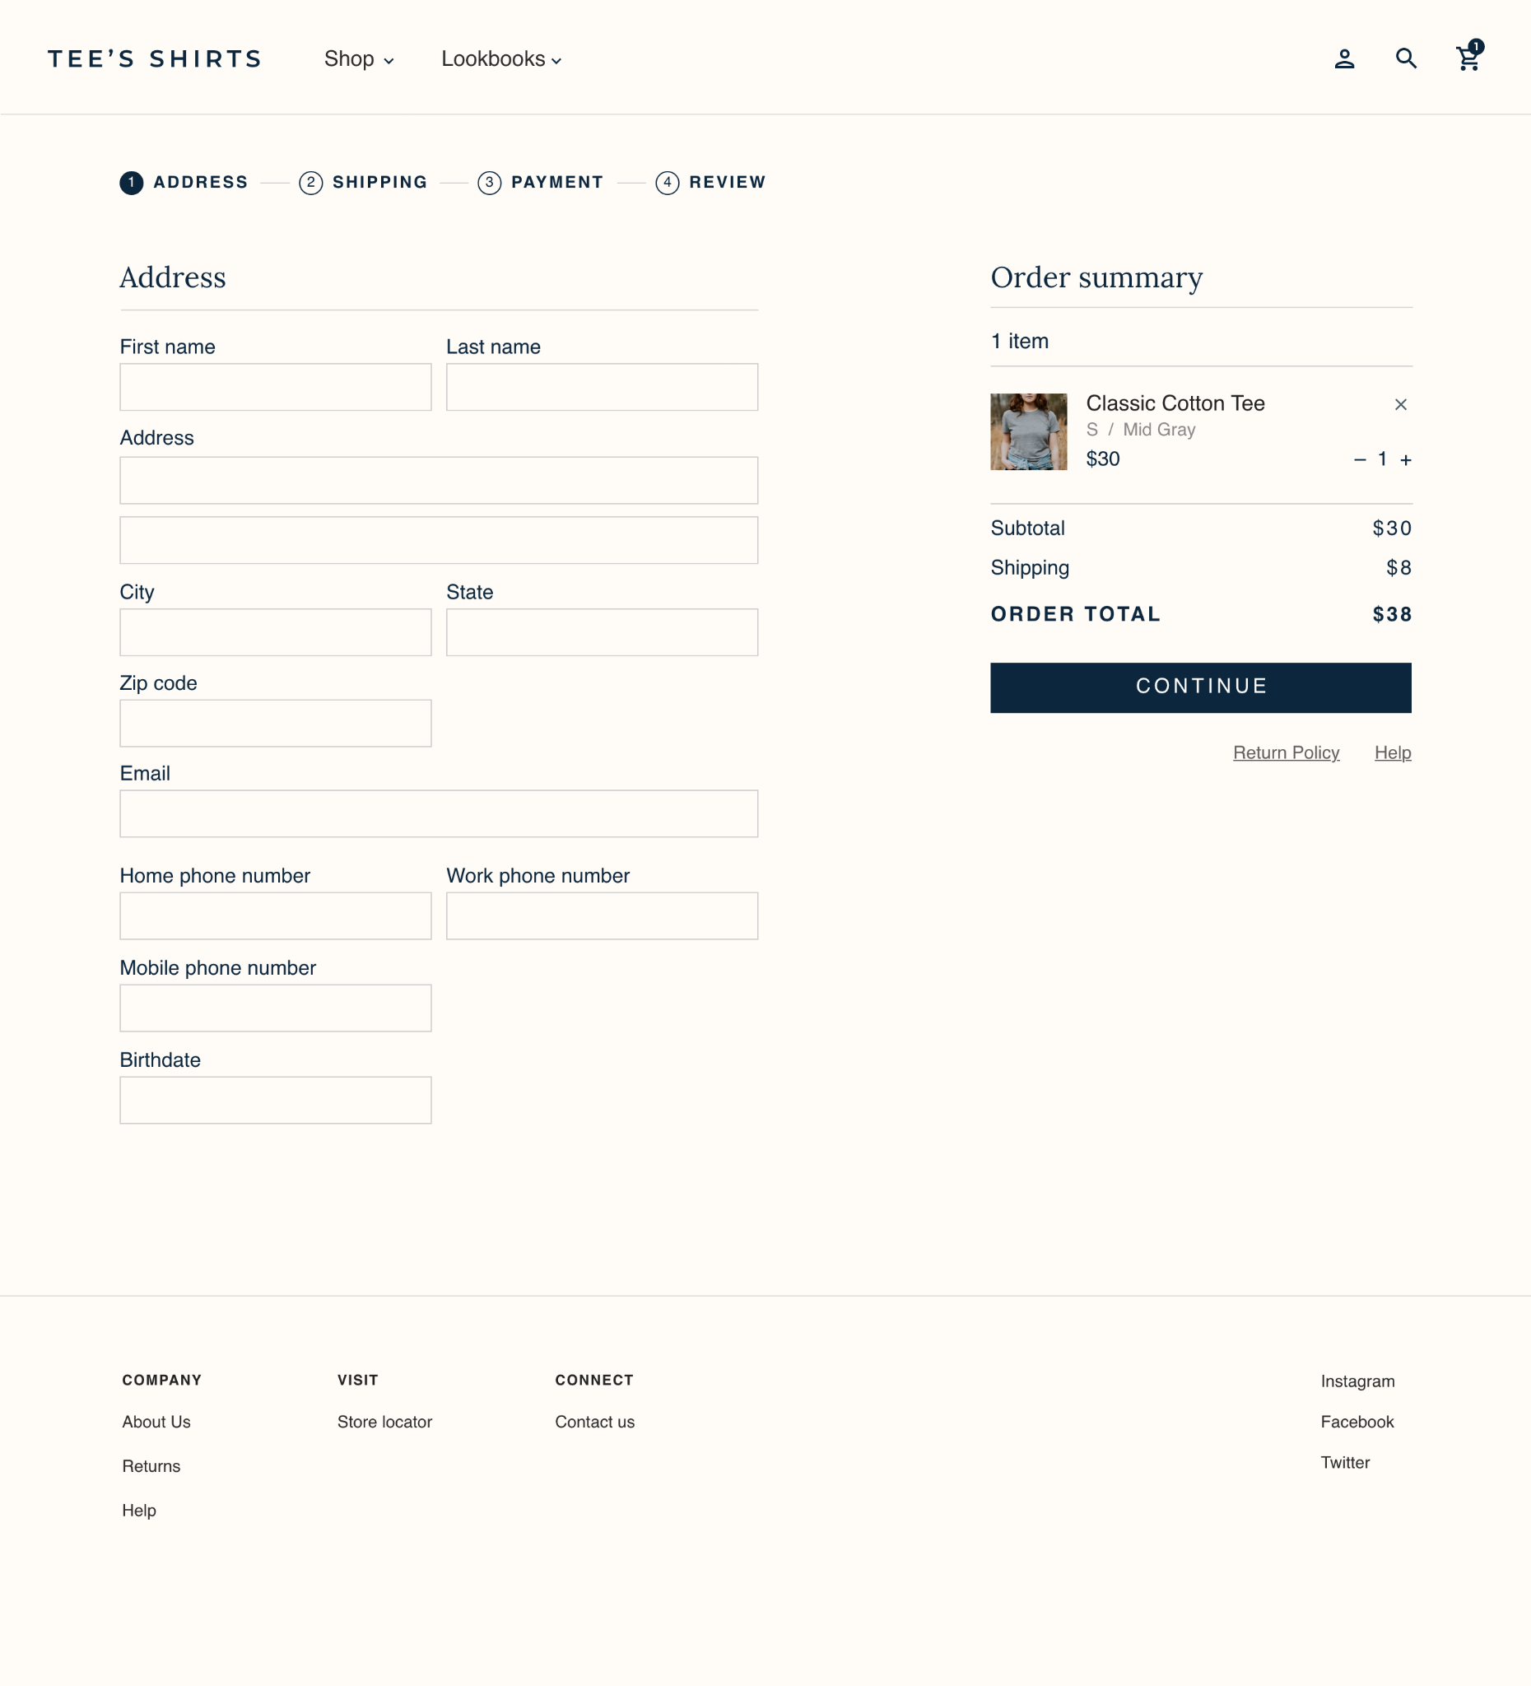

|  |
| --- |
| **Step 1: Identify the issue. Why might customers abandon the checkout process at this point?** |
| The checkout process takes longer for customers to complete because the form includes fields for unnecessary information, such as three different phone numbers and the customer’s birthdate. |

|  |
| --- |
| **Step 2: Suggest improvements. Identify one or two ways to address this issue and improve the checkout process.** |
| 1. Use one field for “Phone” instead of three separate fields for different phone numbers. 2. Remove the field for birthdate. It’s not clear why the store needs to collect this information. |

## 

## **Checkout issue #3: Shipping**



**Situation:**

Customers for Tee’s Shirts are also abandoning the checkout process when asked to choose a shipping option. The shipping options include the following:

* Standard shipping starting at $8
* Express shipping starting at $15

Here is how the store’s shipping options appear during checkout:

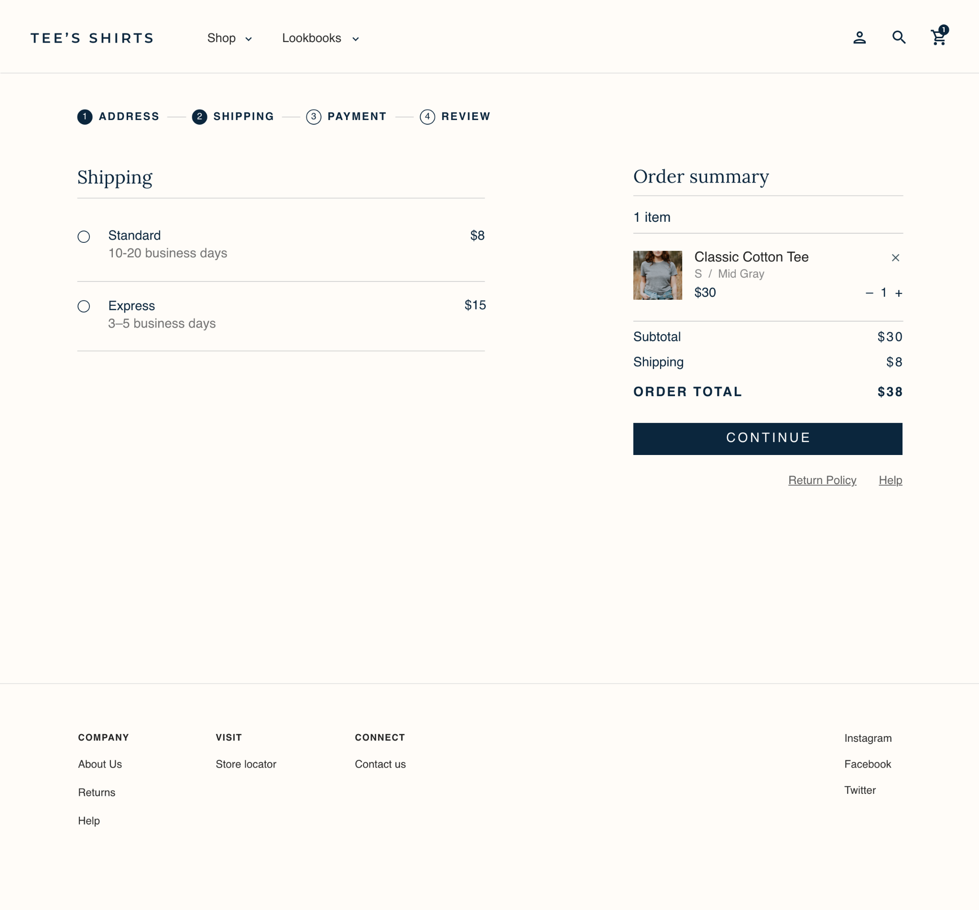

|  |
| --- |
| **Step 1: Identify the issue. Why might customers abandon the checkout process at this point?** |
| Customers may not want to pay for shipping. They might choose to buy from a competitor instead, if the competitor offers free shipping. |

|  |
| --- |
| **Step 2: Suggest improvements. Identify one or two ways to address this issue and improve the checkout process.** |
| 1. Offer free shipping on all orders, or on orders over a certain threshold, such as $25 or more. 2. Offer a promotional code that allows customers to get free shipping. 3. Offer free shipping as a perk for rewards program members. |

## 

## **Checkout issue #4: Payment**



**Situation:**

Customers for Tee’s Shirts are also abandoning the checkout process when asked to enter their payment information. The online store accepts credit cards.

Here is how the store’s payment options appear during checkout:

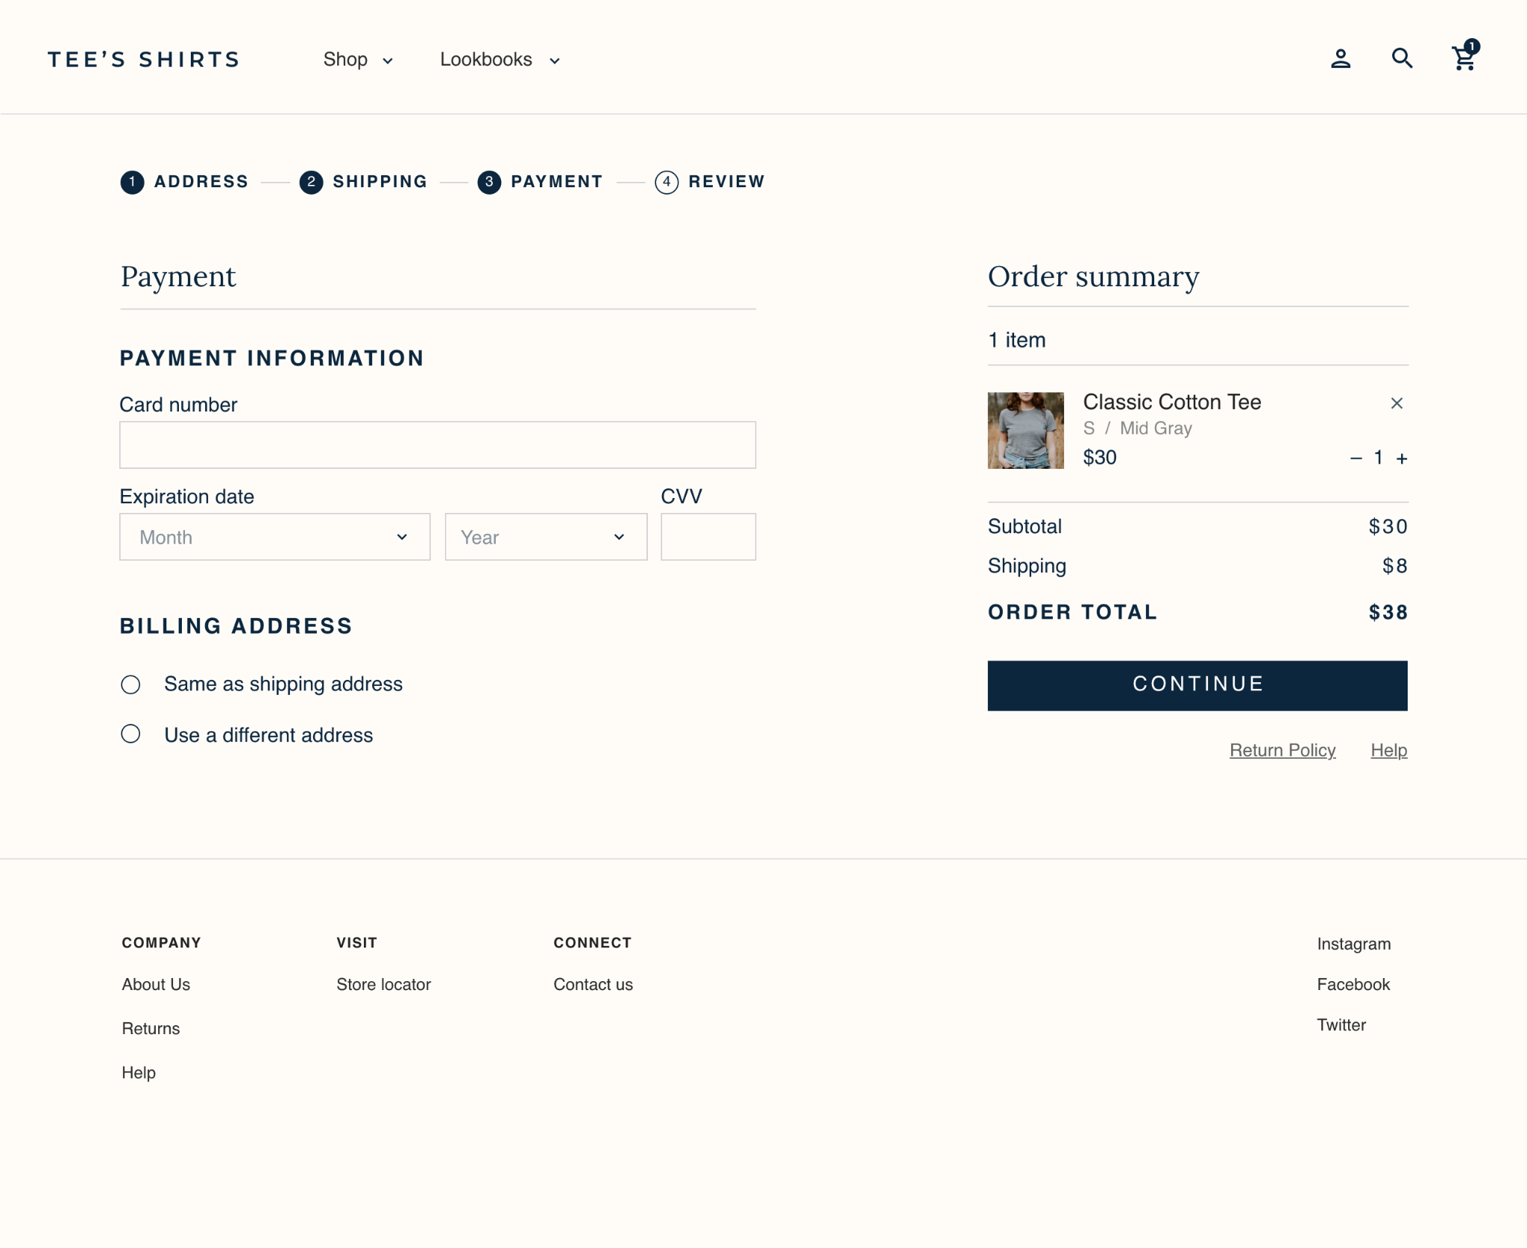

|  |
| --- |
| **Step 1: Identify the issue. Why might customers abandon the checkout process at this point?** |
| Customers may not want or be able to pay with a credit card. They may prefer a more secure payment option, especially if they have any doubts about the security of the store’s website and payment system. |

|  |
| --- |
| **Step 2: Suggest improvements. Identify one or two ways to address this issue and improve the checkout process.** |
| 1. Enable multiple payment methods so that customers can pay using the method they prefer. Other payment methods to consider include debit cards, PayPal, or mobile payments, like Google Pay. Installments can also be a helpful option if customers prefer to buy now and pay later. 2. Make sure the store’s website uses HTTPS. 3. Display a TLS or SSL certificate symbol next to the payment section so that customers know whether they can trust the store’s payment system. |

## 